

**PROJECT DOCUMENTATION**

**Semester: cpiSM**

**NATIONAL PARK**

**Certificate of Completion**

This is to certify that

**MR.SAMI UL HAQ**

**MR.NOMAN JAMSHAID**

**Mr.HUZAIFA KAIMKHANI**

**Mr.muhammad danish**

Has successfully designed and Developed desktop application on

NATIONAL PARK

During e-project of DISM (1ST

Semester)

**APTECH** Worldwide Computer Education,

ORANGI Center Karachi.

# **NATIONAL PARK**

# **THE NATIONAL PARK IN USE CONSERVANTION PURPOSES** **Komodo National Park, East Nusa Tenggara, Indonesia. A national park is a natural park in use for conservation purposes.**

# **Starting in 1735 the Naples government undertook laws in order to protect Natural areas, which could be used as a game reserve by the royal family; Provide was the first protected site;[15] the difference between the many previous royal hunting preserves and this one, which is considered to be closer to a Park rather than a hunting preserve,[16] is that Neapolitan government already considered the division into the present-day wilderness areas and non-strict nature reserves.**

**In 1969, the IUCN declared a national park to be a relatively large area with the following defining characteristics: [12]**

**One or several ecosystems not materially altered by human exploitation and occupation, where plant and animal species, geomorphological sites and habitats are of special scientific, educational, and recreational interest or which contain a natural landscape of great beauty;**

**Highest competent authority of the country has taken steps to prevent or eliminate exploitation or occupation as soon as possible in the whole area and to effectively enforce the respect of ecological, geomorphological, or aesthetic features which have led to its establishment; and**

**Visitors are allowed to enter, under special conditions, for inspirational, educative, cultural, and recreative purposes**

**TABLE OF CONTENT**

COVER PAGE 1

LION 2

TIGER 3

LOE PADER4

KANGAROO5

ELEPHANT6

MARKHOR 7

CONTANT US 8

ABOUT 9

LOGIN 10

**NATIONAL PARK DETAILS:**

national park, an area set aside by a national government for the preservation of the natural environment. A national park may be set aside for purposes of public recreation and enjoyment or because of its historical or scientific interest. Most of the landscapes and their accompanying plants and animals in a national park are kept in their natural state. The national parks in the United States and Canada tend to focus on the protection of both land and wildlife, those in the United Kingdom focus mainly on the land, and those in Africa primarily exist to conserve animals. Several other countries have large areas reserved in national parks, notably Brazil, Japan, India, and Australia.

**NATIONAL PARK:**

* National park, an area set aside by a national government for the preservation of the natural environment. Accept pics individually and via folders
* The creation of Bogd Khan Mountain National Park in Mongolia, which may date from as early as 1778. pics

The national parks of various countries differ greatly in their effectiveness in protecting their resources. Some governments provide their park systems with large enough budgets to make possible strict enforcement of regulations; others do not. Most national parks have a built-in paradox: although they often depend for their existence on tourism stimulated by public interest in nature, the preservation of their wildlife depends on its not being molested. This paradox is usually resolved by allowing visitors to travel only within limited areas in the park.

**Home page:**

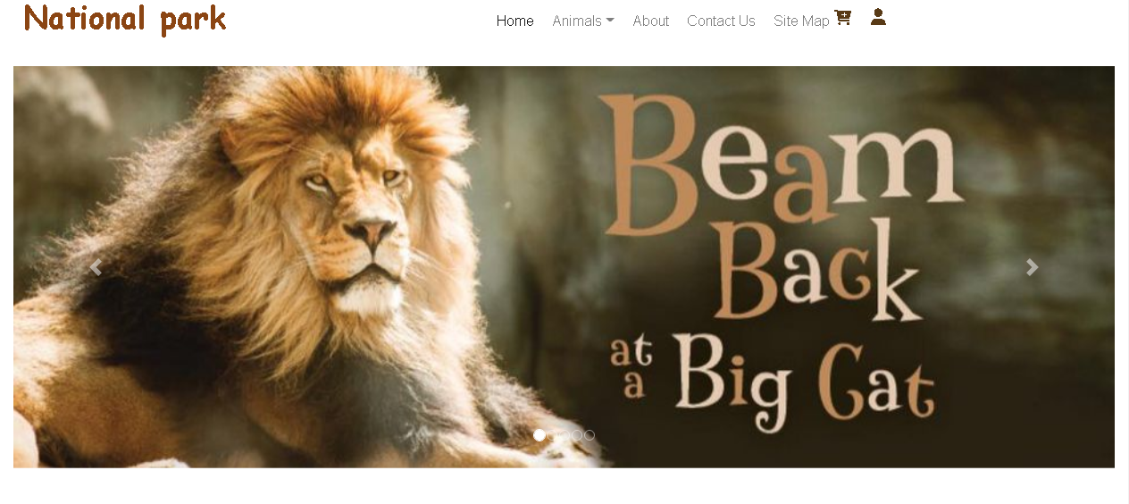

**categories:**

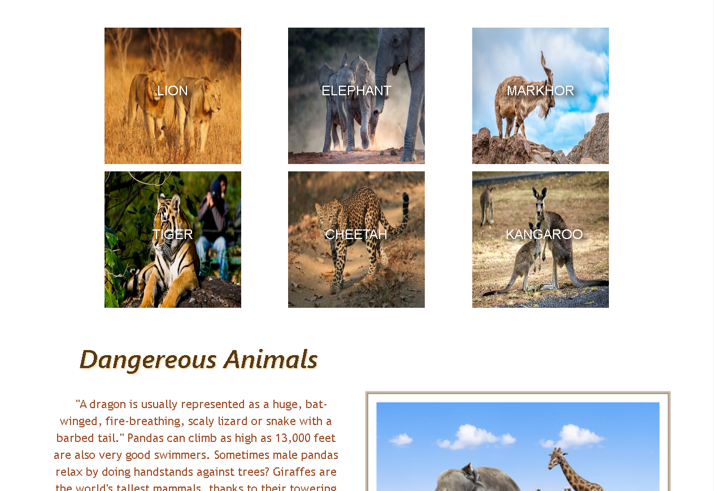

**Screenshots**

**Footer:**

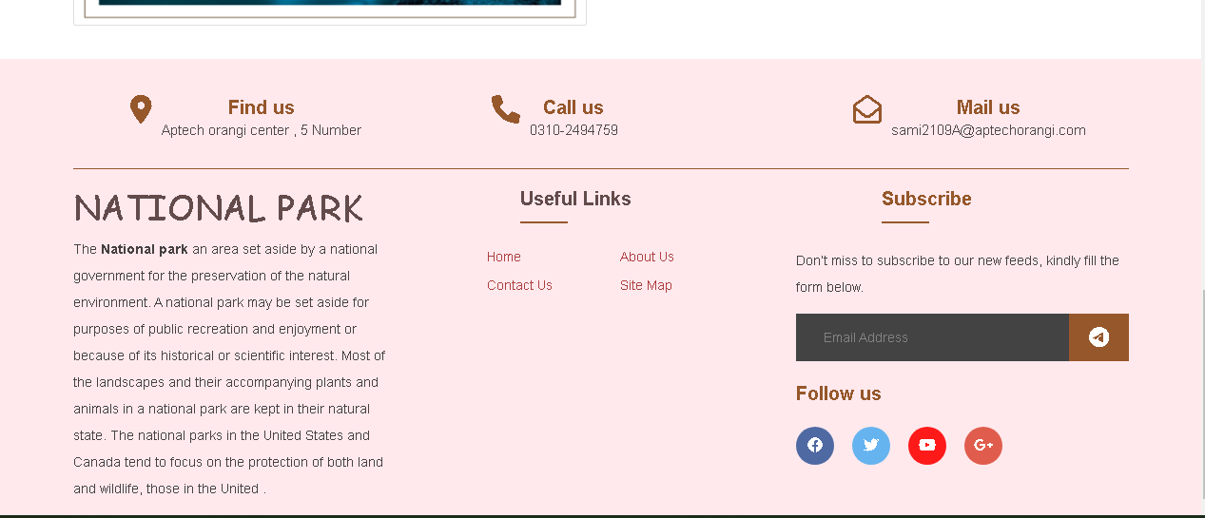

**Contact us:**

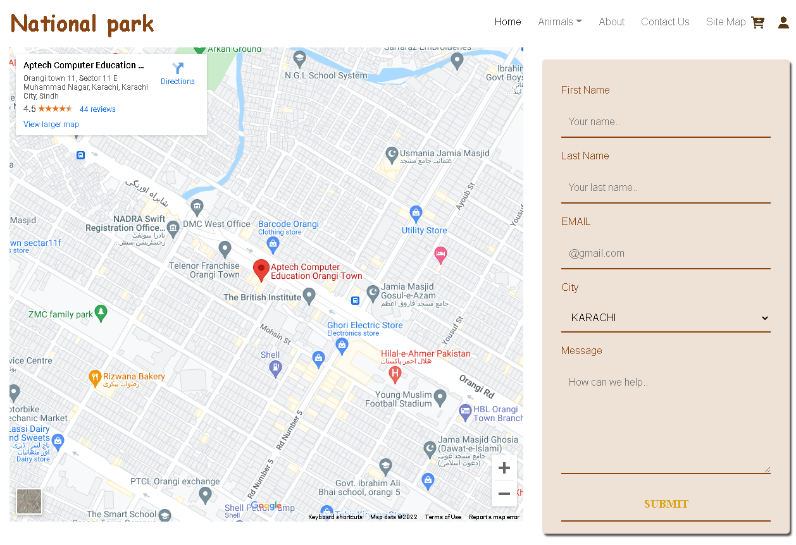

**Login:**

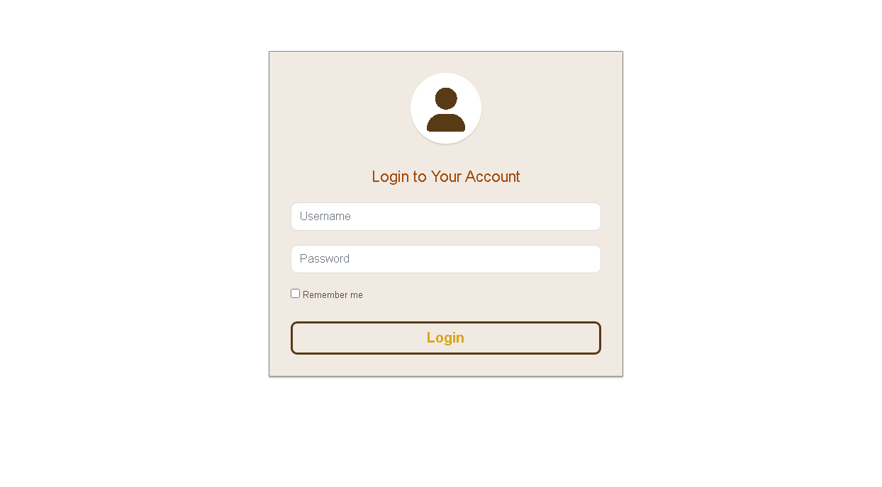

**about:**

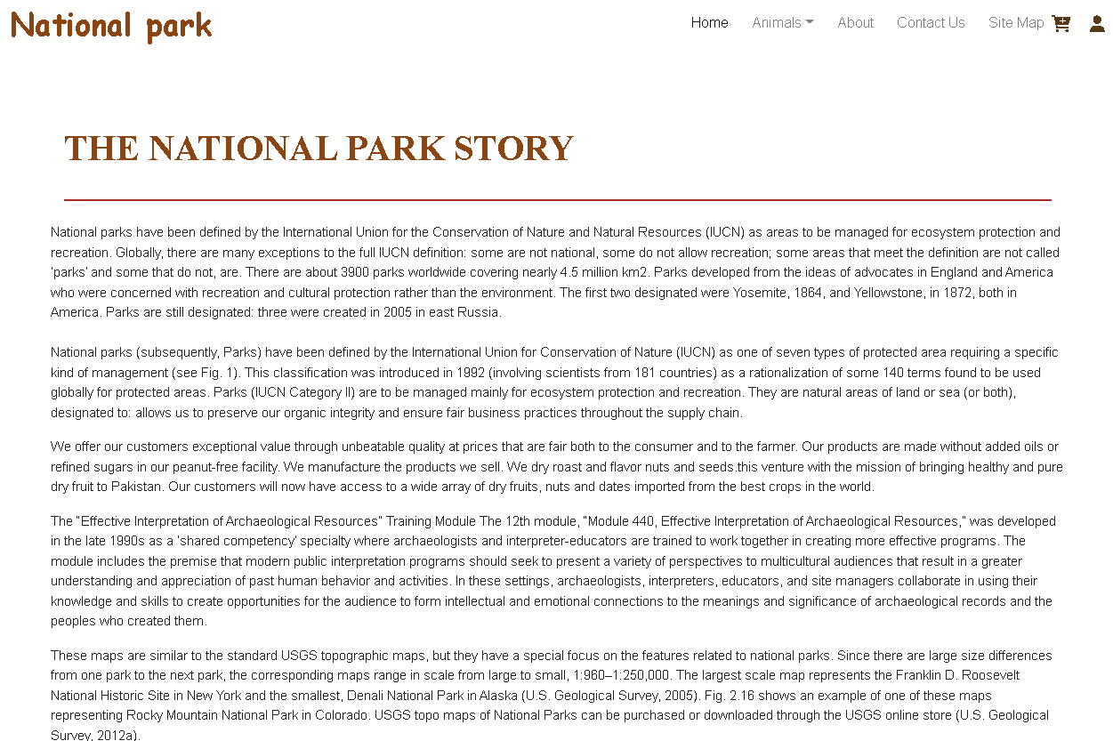

**Preview page:**

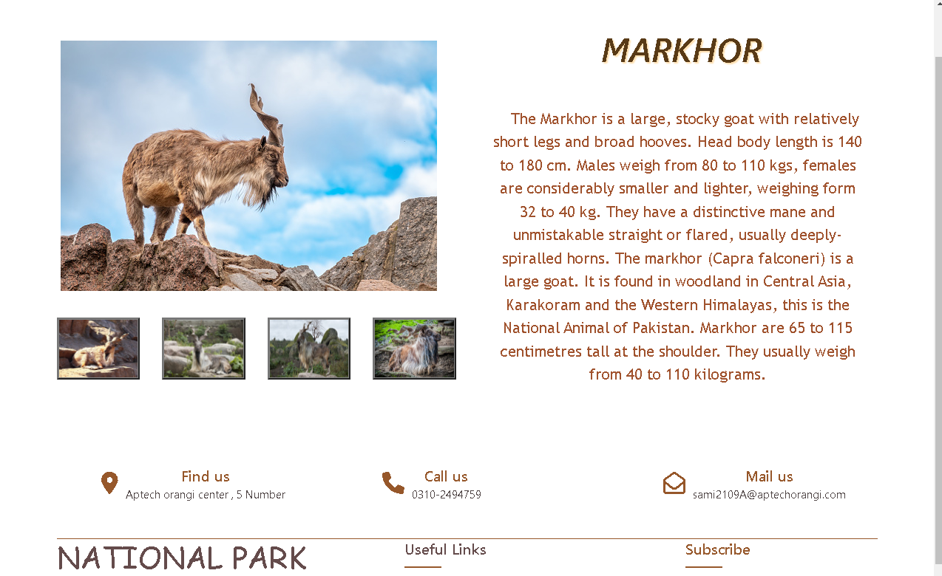

**Task sheet**

|  |  |  |
| --- | --- | --- |
| **Student id** | **name** | **Contribution in project** |
| **1335745** | **SAMI UL HAQ** | **100%** |
| **1346715** | **NOMAN JAMSHAID** | **100%** |
| **1346724** | **HUZAIFA KAIMKHANI** | **100%** |
| **1335152** | **MUHAMMAD DANISH** | **60%** |

**Task sheet**

|  |  |  |  |  |
| --- | --- | --- | --- | --- |
| S.NO | Task | EPROJECT | DONE BY | STATUS |
| 1 | Design | NATIONAL  PARK | SAMI UL HAQ | Completed |
| 2 | Collect  Info | NATIONAL  PARK | NOMAN JAMSHAID | Completed |
| 3 | Redesign  & Code | NATIONAL  PARK | SAMI UL HAQ | Completed |
| 4 | Collect Image | NATIONAL  PARK | HUZAIFA KAIMKHANI | Completed |
| 5 | Documentation | NATIONAL  PARK | ALL | Completed |